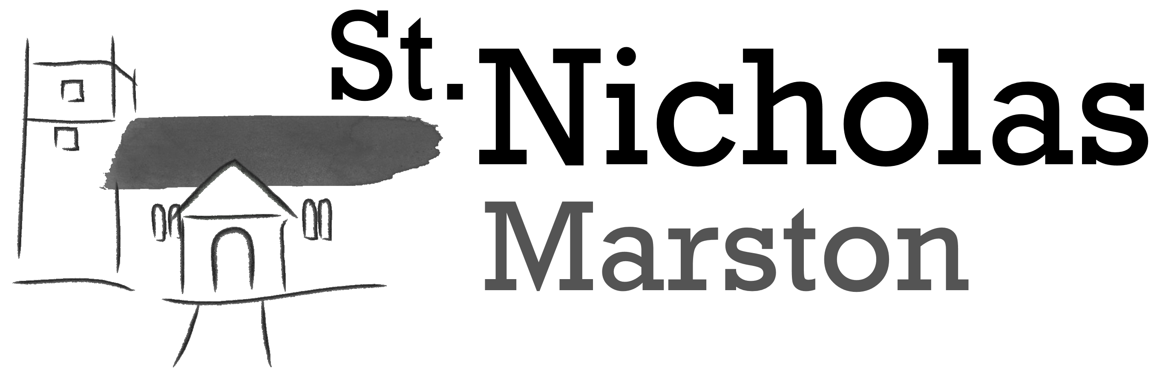

MARRIAGE DETAILS

DATE & TIME OF SERVICE:

COUPLE’S FULL NAMES:

DOB:-
Groom:
Bride:

Occupations:-
Groom:
Bride:

Conditions:-
Groom:
Bride:

Residence at time of Marriage:-

Email address to use for future communication:-

Fathers/Mothers/Parents full names and occupations:-
Groom:

Bride:

Witnesses full names (at least 2):-

1)
2)
3)
4)

Bells: Full/Jr Choir: Veil: Organ:

Printed Order of Service: How many:

No. of rings:- Which vows:-

Music at entry of Bride:-

Hymn 1:-

Bible Reading(s):-

Poem(s):-

Hymn 2:-

Hymn 3 (optional):-

Music during signing of the Marriage Document:-

Music at exit of Bride and Groom:-

Organist:-

Verger (helper on the day from the church):-

Bridesmaids and Bestman:-

Who is giving the Bride away?:-

DATES FOR BANNS:-

WEDDING PREP:-

TIME & DATE OF REHEARSAL:-

PAYMENT:-

Data Protection
Your privacy is important to us and we want to communicate in a way which has your consent and which is line with UK law and data protection. We have a legal obligation to store some information in registers but in addition, we ask you to consider giving your consent to the following:-
Please tick the boxes below as appropriate

I/we agree for the above details and other information to be stored for the above purpose only.
I/we agree for the above details and other information to be stored so that we can be informed about the Wedding Blessing service and other related events for those recently married.
I/We would love to stay in touch! I/we agree for the details to be stored on the mailing list which provides up-to-date information on all church events and actives in Marston.

You can withdraw your consent to any of the purposes at any time by contacting the church office by email administrator@stnicholasmarston.org.uk or by phone on 01865 580354
Signed ___________________________________ Dated_______________________________

